

**SOFTWARE DESIGN**

**MES3043**

**Topic: UPSI STREET (PRELOVED ITEMS)**

**GROUP C**

**Lecturer’s name:** Dr. Suliana binti Sulaiman

**Group members:**

1. Nur Atikah Binti Mohamad (D20161072642)
2. Muhammad Abdin Shakirin Bin Mohamad (D20161074854)
3. Ku Mohamad Hafidz Bin Ku Mohamad Hashim (D20161074857)
4. Nur Syakirah Binti Mohamed Shah Beri (D20161072556)
5. Mohamad Zulhelmi Bin Mohd Zaini (D20162075287)

**Type of Requirement Technique used: Interview & Brainstorming**

**1.0 FUNCTIONAL REQUIREMENTS**

1. **The software application shall have log-in function for:**
   1. **Students**
      1. Students that has already been registered as UPSI students will be able to use this application with a given account with default password (IC number) and default ID (matric number)
      2. Students verify him/herself by entering the pin code sent by SMS service during registration process.
      3. Only registered students can access this application.
      4. Students can change password account for safety.
   2. **Admin**
      1. Admin will be given a default account using Staff ID.
      2. Admin can change password account for safety.
2. **The software application shall have the ability for:**
   1. **Students**
      1. Students can search preloved items by using item categories and hot items provided.
      2. Students can buy preloved items by adding the items into the cart provided.
      3. Students can view the items they bought in the cart.
      4. Buyers can make payment through cash on delivery/cash deposit machine/ online banking.
      5. Buyers can view payment receipt.
      6. Buyers can view shopping history.
      7. Students can sell their preloved items by adding the items in sell items section.
      8. Students can delete the items after sold.
      9. Students can submit feedback by giving rate to the seller.
      10. Students can tag their favourite seller to receive notifications.
      11. Students can chat online with each other in the application.
      12. Students can log out the application at any time.

**2.2 Admin**

* + 1. Admin can monitor transaction process.
    2. Admin can maintain the system.

**User Interface Requirements**

1. The software application shall have:
   1. Log in interface which include:
      1. Sign up button
      2. Matric num
      3. Password
      4. Forgot password
      5. Log in button
2. The software system at the user interface shall have:
   1. Search Items
   2. Category
   3. My purchases
   4. Hot Items
   5. History
   6. My cart
   7. My selling items
   8. Sell transaction
   9. Feedback
   10. Help

**Performance Requirements**

1. The software system shall support:
   1. Android 6.0 and above
   2. IOS 9 and above
   3. Strong internet connection to download apps (48Mb)

**2.0 USE CAS­E DIAGRAM FOR UPSI STREET SYSTEM**

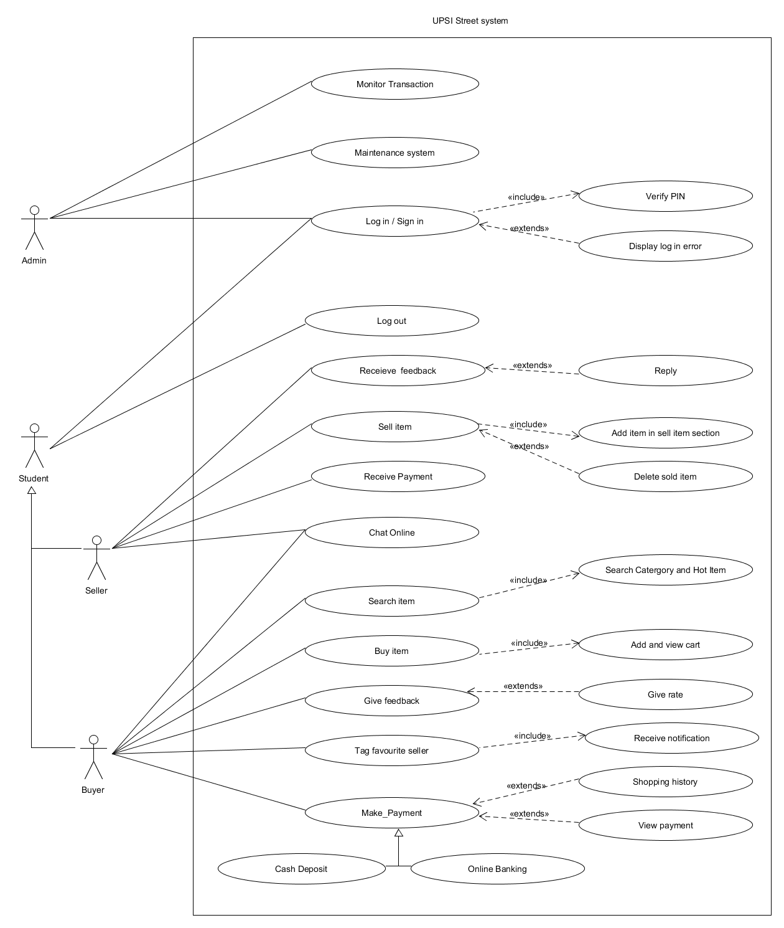

submit

change password

insert id

)

matric no

(

insert password

ic number

)

(

confirm new password

verify password

**3.0 ACTIVITY DIAGRAM WITH USE CASE DESCRIPTION**

3.1. For Admin and UPSI Student( Buyer and Seller)

3.1.1 Log in

|  |  |
| --- | --- |
| Usecase name | Login system |
| Use Case ID | UC01 |
| Author | Nur Atikah Binti Mohamad |
| Date | 24/3/2018 |
| Actors | UPSI Students (Buyer, Seller), Admin |
| Description | User who already have an account, they can log in into the system to perform the functionality effectively. |
| Preconditions | 1. Admin already have a verified account to manage the system, while the student need to register first using their “matric id” for login into the system. 2. UPSI Street system functioning |
| Basic steps | 1. Admin / Student entered the UPSI Street system site 2. UPSI Street system display screen to log in into the system 3. Student key in matric id as their ID and their IC number as password, while admin enter ID and password as security to manage the system. 4. User must click sign in button to perform the system functionality. 5. UPSI Street system verify the ID and password by using SMS verification |
| Exceptions | 1. ID or password cannot be verified 2. UPSI Street display error message wrong ID or password 3. UPSI Street repeat step 5 |
| Business validation/Rules | 1. Student must register to allow them to log in into the system 2. User must have at least 12 characters for length of ID 3. Admin must have at least 10 characters for length of password |
| Post conditions | User can log in into the system. |

3.1.2 Log out

Logout

View Menu

Login

|  |  |
| --- | --- |
| Usecase name | Logout |
| Use Case ID | UC02 |
| Author | Mohamad Zulhelmi Bin Mohd Zaini |
| Date | 24/3/2018 |
| Actors | UPSI Students (Buyer, Seller), Admin |
| Description | The user of this system wants to terminates from the system |
| Preconditions | 1. Admin already have a verified account to manage the system, while   the student need to register first using their “matric id” for login into  the system.   1. UPSI Street system functioning |
| Basic steps | 1.Admin / the student entered the UPSI Street system site  2.UPSI Street system display screen to log in into the system  3. Student key in matric id as their ID and their IC number as password,  while admin enter ID and password as security to manage the system.   1. Admin/Student click sign in button to perform their job. 2. Admin/Student already performed their job. 3. Admin/Student click Logout button. 4. Admin/Student terminates from the system. |
| Exceptions | 1. ID or password cannot be verified 2. UPSI Street display error message wrong ID or password 3. UPSI Street repeat step 5 |
| Business validation/Rules | 1. Student must register to allow them to log in into the system 2. User must have at least 12 characters for length of ID 3. Admin must have at least 10 characters for length of password |
| Post conditions | The user terminates from the system. |

* 1. For UPSI Student( Buyer)

3.2.1 Search items

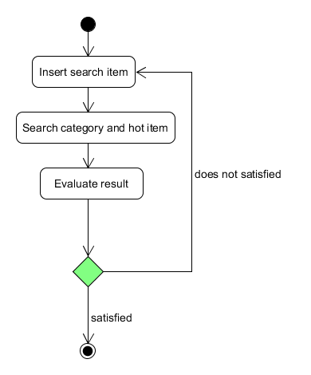

|  |  |
| --- | --- |
| Use case name | Search items |
| Use Case ID | UC03 |
| Author | Nur atikah binti mohamad |
| Date | 24/3/2018 |
| Actors | UPSI students (Buyer) |
| Description | Buyer search preloved items sell in the application. |
| Preconditions | 1. Buyer must be a registered student to access the system 2. UPSI Street system functioning. |
| Basic steps | 1. Buyer entered the UPSI Street system site 2. UPSI Street system site display homepage 3. Buyer click on search button 4. Buyer search items based on categories and hot items provided |
| Exceptions | 1. Search category not available 2. Item searched is wrongly placed in category |
| Business validation/Rules | 1. Student must have verified account with ID and password. 2. Student must log in into the system. |
| Post conditions | The items can be found |

* + 1. Buy items

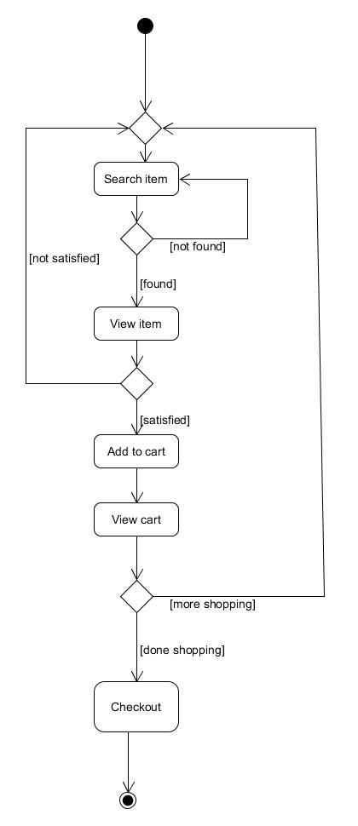

|  |  |
| --- | --- |
| Use case name | Buy items |
| Use Case ID | UC04 |
| Author | Nur atikah binti mohamad |
| Date | 24/3/2018 |
| Actors | UPSI students (Buyer) |
| Description | Buyer buy preloved items sell in the application. |
| Preconditions | 1. Buyer must be a registered student to access the system 2. UPSI Street system functioning. |
| Basic steps | 1. Buyer entered the UPSI Street system site 2. UPSI Street system site display homepage 3. Buyer search the items 4. Buyer buy the items they wanted by adding the items to the cart provided 5. Buyer view the items they bought in the cart |
| Exceptions | 1. Item already sold or not available. |
| Business validation/Rules | 1. Student must have verified account with ID and password. 2. Student must log in into the system. |
| Post conditions | The items can be bought. |

* + 1. Tag Favourite Seller

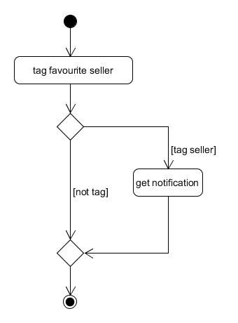

|  |  |
| --- | --- |
| Use Case Name | Tag Favourite Seller. |
| Use Case ID | UC05 |
| Author | Mohamad Zulhelmi Bin Mohd Zaini |
| Date | 25/3/2018 |
| Actors | UPSI Students.(Buyer) |
| Description | The buyer can tag their favourite seller to receive notification. |
| Preconditions | 1. Buyer must be a registered student to access to the system.  2. UPSI Street system functioning. |
| Basic Steps | 1. The buyer entered the UPSI Street system site. 2. UPSI Street system site display homepage. 3. The buyer search their favourite seller. 4. The buyer tag their favourite seller. 5. The buyer get notification from their device when their favourite seller posted their new item. |
| Exceptions | The buyer must have internet connection from his device to get the notification that the seller posted. |
| Business  Validation/ Rules | 1. Student must have verified account with ID and password. 2. Student must log in into the system. |
| Post condition | The student get notification about what their favourite seller new post. |

* + 1. Give Feedback

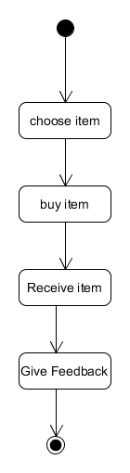

|  |  |
| --- | --- |
| Use Case Name | Give Feedback |
| Use Case ID | UC06 |
| Author | Mohamad Zulhelmi Bin Mohd Zaini |
| Date | 25/3/2018 |
| Actors | UPSI Students (Buyer). |
| Description | The students can give the feedback to the student that sell the item. |
| Preconditions | 1. Buyer must be a registered student to access to the system.  2. UPSI Street system functioning. |
| Basic Steps | 1. The buyer entered the UPSI Street system site. 2. UPSI Street system site display homepage. 3. The buyer buy the item from the site. 4. The student give feedback to the seller. |
| Exceptions | N/A |
| Business  Validation/ Rules | 1. Student must have verified account with ID and password. 2. Student must log in into the system. |
| Post condition | The seller receive feedback from the student that sell the item |

3.2.5 Make Payment

cash on delivery

online banking

view payment

receipt

make payment

|  |  |
| --- | --- |
| Use case name | Make payment |
| Use Case ID | UC07 |
| Author | Nur Syakirah Binti Mohamed Shah Beri |
| Date | 24/3/2018 |
| Actors | UPSI students(Buyer) |
| Description | Buyer make payment through cash payment or online banking |
| Preconditions | 1. Buyer must be a registered student to access the system  2. UPSI Street system functioning |
| Basic steps | 1. Buyer entered the UPSI Street system site 2. UPSI Street system site display homepage 3. Buyer search items based on category 4. The buyer buy the items 5. Buyer click on payment button 6. Buyer can chooses online banking or cash payment 7. Buyer entered the total money of items into the account 8. UPSI Street System view payment receipt |
| Exceptions | 1. Buyer do not have bank account number 2. Online banking cannot be done |
| Business  Validation/Rules | 1. Student must have verified account with ID and password 2. Student must log in into the system |
| Post conditions | The buyer successful buy the item |

* 1. For UPSI Student (Seller)

3.3.1 Sell Item

Delete sold item

Add item

Sell item

|  |  |
| --- | --- |
| Use case name | Sell items |
| Author | Nur Atikah Binti Mohamad |
| Use Case ID | UC08 |
| Date | 24/3/2018 |
| Actors | UPSI students (Seller) |
| Description | Seller sell preloved items in the application. |
| Preconditions | 1. Seller must be a registered student to access the system 2. UPSI Street system functioning. |
| Basic steps | 1. Seller entered the UPSI Street system site 2. UPSI Street system site display homepage. 3. Seller add item to My Selling Item section. 4. Seller selects category for the item that they want to sell. 5. Seller gives description about the item that they want to sell. 6. Seller give price on the item that they want to sell. 7. UPSI Street’s system displays the item based on the category. 8. Seller delete the item that had been sold. |
| Exceptions | 1. Item is illegal and the system blocks the progress. |
| Business validation/Rules | 1. Student must have verified account with ID and password. 2. Student must log in into the system. |
| Post conditions | The items can be displayed on the selling items and sold. |

3.3.2 Receive Feedback

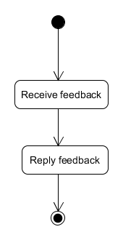

|  |  |
| --- | --- |
| Use Case Name | Receive Feedback |
| Use Case ID | UC09 |
| Author | Mohamad Zulhelmi Bin Mohd Zaini |
| Date | 25/3/2018 |
| Actors | UPSI Students (Seller). |
| Description | The seller received the feedback from the buyer that already buy his/her items . |
| Preconditions | 1. Seller must be a registered student to access to the system.  2. UPSI Street system functioning. |
| Basic Steps | 1. The seller entered the UPSI Street system site. 2. UPSI Street system site display homepage. 3. The seller buy the item from the site. 4. The seller received feedback from the buyer. |
| Exceptions | N/A |
| Business  Validation/ Rules | 1. Student must have verified account with ID and password. 2. Student must log in into the system. |
| Post condition | The seller receive feedback from the student that sell the item |

3.3.2 Receive Payment

View Payment

Details

Receive Payment

|  |  |
| --- | --- |
| Use Case Name | Receive Payment |
| Use Case ID | UC10 |
| Author | Nur Syakirah Binti Mohamed Shah Beri |
| Date | 25/3/2018 |
| Actors | UPSI Students (Seller). |
| Description | The seller received the payment from the buyer |
| Preconditions | 1. Seller must be a registered student to access to the system.  2. UPSI Street system functioning. |
| Basic Steps | 1. The seller entered the UPSI Street system site. 2. UPSI Street system site display homepage. 3. The seller received payment from the buyer. 4. The seller click item information 5. The seller view the payment description. |
| Exceptions | N/A |
| Business  Validation/ Rules | 1. Student must have verified account with ID and password. 2. Student must log in into the system. |
| Post condition | The seller deliver the item to the seller. |

* 1. For UPSI Student (Buyer/Seller)

3.4.1 Chat Online

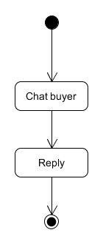

|  |  |
| --- | --- |
| Use Case Name | Chat Online |
| Use Case ID | UC11 |
| Author | Mohamad Zulhelmi Bin Mohd Zaini |
| Date | 25/3/2018 |
| Actors | UPSI Students (Seller, Buyer) |
| Description | Buyer/Seller can chat with each other via chat room. |
| Preconditions | 1. Buyer and seller must be a registered student to access to the system. 2. UPSI Street system functioning. |
| Basic Steps | 1. Buyer/Seller entered the UPSI Street system site. 2. UPSI Street system site display homepage 3. The buyer search the item. 4. The item displayed with the description and chat room . 5. The buyer chat the seller to know the information of the item. 6. The seller reply chat from the buyer. |
| Exceptions | The buyer/seller that buy/sell the item must have internet connection from his device to get the chat from the student that wants to buy his item. |
| Business  Validation/ Rules | 1. Student must have verified account with ID and password. 2. Student must log in into the system. |
| Post condition | Buyer and seller can interact with each other |

* 1. For Admin

3.5.1 Monitor Transaction

view report

from user

view item,

transaction history

click monitor

transaction button

|  |  |
| --- | --- |
| Use case name | Monitor transaction |
| Use Case ID | UC12 |
| Author | Nur Syakirah Binti Mohamed Shah Beri |
| Date | 24/3/2018 |
| Actors | Admin |
| Description | Admin monitor the transaction |
| Preconditions | 1. Admin must be a registered admin to access the system  2. UPSI Street system functioning |
| Basic steps | 1. Admin entered the UPSI system site 2. UPSI Street System site display homepage 3. Admin click monitor transaction button 4. Admin chooses report button 5. UPSI Street System view report from user 6. Admin chooses history button 7. UPSI Street System view transaction history 8. Admin chooses available item button 9. UPSI Street System view item available |
| Exceptions | N/L |
| Business  Validation/Rules | 1. Admin must have verified account with ID and password  2. Admin must log in into the system |
| Post conditions | Admin can monitor the transaction in the system |

3.5.2 Maintenance system

view report

from user

view system

functionality

click maintanance

button

|  |  |
| --- | --- |
| Use case name | Maintenance system |
| Use Case ID | UC13 |
| Author | Nur Syakirah Binti Mohamed Shah Beri |
| Date | 24/3/2018 |
| Actors | Admin |
| Description | The buyer make payment through cash payment or online banking |
| Preconditions | 1. Admin must be a registered admin to access the system  2. UPSI Street system functioning |
| Basic steps | 1. Admin entered the UPSI system site  2. UPSI Street System site display homepage  3. Admin click maintenance button  4. Admin chooses report button  5. UPSI Street System view report from user  6. Admin chooses system functionality button  7. UPSI Street System view system functionality |
| Exceptions | N/L |
| Business  Validation/Rules | 1. Admin must have verified account with ID and password 2. Admin must log in into the system |
| Post conditions | Admin can control the maintenance of the system |